**Exercise : Reverse a Linked List**

**21102050 Lee In Sun 이인선**

import java.io.*;

import java.math.*;

import java.security.*;

import java.text.*;

import java.util.*;

import java.util.concurrent.*;

import java.util.regex.*;

public class Solution {

static class SinglyLinkedListNode {

public int data;

public SinglyLinkedListNode next;

public SinglyLinkedListNode(int nodeData) {

this.data = nodeData;

this.next = null;

}

}

static class SinglyLinkedList {

public SinglyLinkedListNode head;

public SinglyLinkedListNode tail;

public SinglyLinkedList() {

this.head = null;

this.tail = null;

}

public void insertNode(int nodeData) {

SinglyLinkedListNode node = new SinglyLinkedListNode(nodeData);

if (this.head == null) {

this.head = node;

} else {

this.tail.next = node;

}

this.tail = node;

}

}

public static void printSinglyLinkedList(SinglyLinkedListNode node, String sep, BufferedWriter bufferedWriter) throws IOException {

while (node != null) {

bufferedWriter.write(String.valueOf(node.data));

node = node.next;

if (node != null) {

bufferedWriter.write(sep);

}

}

}

public static SinglyLinkedListNode reverse(SinglyLinkedListNode llist) {

if(llist == null) {

return null;

}

SinglyLinkedListNode prevNode = null;

SinglyLinkedListNode curNode = llist;

SinglyLinkedListNode nextNode = null;

while(curNode != null) {

nextNode = curNode.next;

curNode.next = prevNode;

prevNode = curNode;

curNode = nextNode;

}

llist = prevNode;

return llist;

}

private static final Scanner scanner = new Scanner(System.in);

public static void main(String[] args) throws IOException {

BufferedWriter bufferedWriter = new BufferedWriter(new FileWriter(System.getenv("OUTPUT_PATH")));

int tests = scanner.nextInt();

scanner.skip("(\r\n|[\n\r\u2028\u2029\u0085])?");

for (int testsItr = 0; testsItr < tests; testsItr++) {

SinglyLinkedList llist = new SinglyLinkedList();

int llistCount = scanner.nextInt();

scanner.skip("(\r\n|[\n\r\u2028\u2029\u0085])?");

for (int i = 0; i < llistCount; i++) {

int llistItem = scanner.nextInt();

scanner.skip("(\r\n|[\n\r\u2028\u2029\u0085])?");

llist.insertNode(llistItem);

}

SinglyLinkedListNode llist1 = reverse(llist.head);

printSinglyLinkedList(llist1, " ", bufferedWriter);

bufferedWriter.newLine();

}

bufferedWriter.close();

scanner.close();

}

}

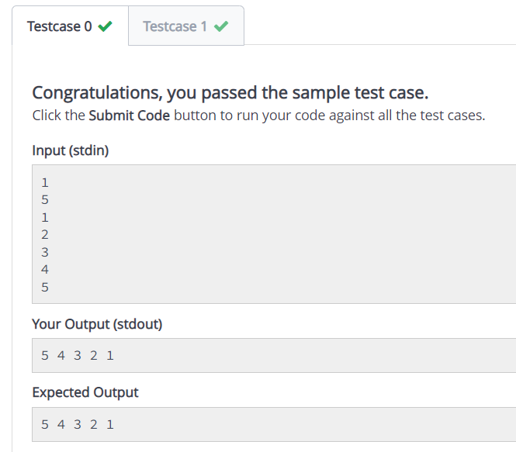Output

